Grandmont Rosedale Community Development Corporation
Neighborhood Stabilization Program
Detroit, Michigan

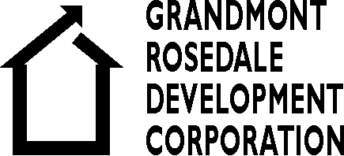
Marketing Programs For Renovated Foreclosed Homes

Lisa Danovich ASID
March 15, 2011

I. Executive Summary

Grandmont Rosedale Community Development Corporation (GRDC) has a 21-year history of Community development the group of five adjacent neighborhoods in Detroit, Michigan. Because the economic conditions in Detroit has had a negative impact on many Detroit neighborhoods. This strong community with one of the finer building stock of Detroit has not been unaffected by the serious problems of the city. Foreclosed properties left vacant product blight and attract vandals and more serious crime. Neighborhood housing values have dramatically decreased, causing a snowballing devaluation effect. Crime has infiltrated the neighborhood and theft, and home invasions are common.

GRDC has been a community resource providing referrals for foreclosure assistance, and leading vacant property maintenance and security patrol. Through foundation funding and inclusion in Detroit’s revitalization programs, GRDC has taken on an ambitious program to stabilize the neighborhoods through a foreclosure purchase, renovation and sales program, “The Neighborhood Restabilization Program”.

Within this program a marketing plan to sell the homes has been initiated with includes many aspects including a neighborhood “branding”, a home “staging”, volunteer neighborhood “ambassador”, and other marketing strategies. As a MSW intern given the task to create and manage the staging and ambassador programs for GRDC, the use of community assessment evaluation tools and a relevant literature review was made to incorporate a theoretical basis for the planning and implementation of the programs.

II. Acknowledgments

I would like to acknowledge and thank all those at GRDC who contributed to this program with information, especially Cathy Marshall, Brad Mattison. Marcia Closson of the North Rosedale Park Community Association provided access to historic newsletter articles (The Tattler) and other neighborhood events documents. Professor Janet Ray of the University Of Michigan- Ann Arbor provided guidance for which this document would not have been possible.

III. Organizational Background

Grandmont Rosedale Development Corporation
GRDC was established in 1989 as a non-profit neighborhood organization with a mission to maintain the neighborhood's home values. Over the years, this has included strategies of playground renovations, forgivable and low-interest loans for property improvements including business facade matching grants, purchasing and renovating residential and business property, building new homes, sidewalk and street renovations, a farmer's market, neighborhood security and vacant home board-ups, among other projects. GRDC acts as a liaison for resources and fosters neighborhood community action and activity.
GRDC funds these projects with grants from foundations and organizations and by acting as an agent for some home loan programs. GRDC is currently funded by the Ford and Kresge Foundations to tackle an ambitious mission to purchase, renovate and resell 350 foreclosed homes over the next five years, and currently has the first ten residences in the works, with the first renovated home selling in the month of January 2011. Repopulating the neighborhood is intended to increase personal and property protection as well as stabilize real estate values, which maintains the personal assets of the residents. Stabilizing the neighborhood on many fronts is the goal. This neighborhood would like to be considered as a neighborhood of choice for many years to come, and be part of the Detroit revitalization program (NSP3) developed by the city of Detroit.

Historic Background
In Detroit, Michigan, one of the most desirable areas to live in is the Grandmont-Rosedale group of five adjacent neighborhoods on the northwest side. This neighborhood was first established in the 1920's by a group of businessmen for their own families. The finely crafted homes were individually custom designed and built for each owner. Deeds were issued to families of financial means who fit a racial profile specifically excluding African Americans and people of color. Some of the leading executives raised their families in this charming and homogeneously WASP neighborhood.
During the 60's in Detroit general racial oppression and exclusion inspired activism,
demonstrations and riots by the African-American citizens. The US Supreme Court decisions: Brown Versus the Board of Education in 1954 and in 1971 Swan Versus Charlotte-Mecklinburg Board of Education address this racial discrimination of school children by desegregation of schools. Children were bussed to schools in other neighborhoods to foster educational equality and racial mixing. Bigotry was so strong that what is referred to as "white flight" occurred throughout the city of Detroit. A few of the grander neighborhoods like Grandmont Rosedale and Palmer Park retained a higher percentage of white residents as the affluent and well-educated African-Americans began to purchase homes in these neighborhoods.
Over the following decades, the racial mixture eventually reversed itself, in that as of the 2008 census estimate by Detroit Drill Down, the ratio of African- American to white residents was 84.4% to 12.3%. Many of the 12.3% white population appear to be long-time residents. Today the neighborhood still has many community activities that are absent in other neighborhoods, and a strong amount of community pride is still evident. However, there is an economic crisis in Detroit and in the US that also has a negative impact on the Grandmont Rosedale neighborhoods.
With the globalization and resulting factory closures, followed by the banking disaster of the late 2000’s and the resulting high unemployment at approximately 20%, according to the October 2010 statistics by the Bureau of Labor, along with general flight to pursue jobs outside of Detroit, abandonment and home foreclosures present a devastating effect and destabilize all neighborhoods in Detroit, even this once affluent neighborhood. There are about 660 foreclosed homes in the neighborhood of about 5700 households.
Crime has taken over the neighborhoods with burglaries, robberies and home
invasions. Vacant homes are broken into and copper piping, along with other fixtures and an increasingly desperate unemployed population strips features for resale. Drug use and sales, and other crimes of desperation are on the increase throughout Detroit and seeping into the more stable neighborhoods as well.

Clientele/Stakeholders to Engage

The main stakeholder GRDC is concerned about engaging are the 350 homebuyers for renovated, foreclosed homes during the next five years. Secondary stakeholders are the GRDC staff and membership, including neighborhood associations, the funding foundations and the general neighborhood residents. For the docent program, resident volunteers will be generated, as will a staging partnership with a furnishings company.

The action plan developed for stabilizing the neighborhoods affects all stakeholders. However, in order to repopulate the vacant foreclosed homes, the homebuyer is the target for engagement. GRDC does not discriminate and their mission and strategies are inclusive of all persons– no matter which racial and ethnic, socio-economic, gender, sexual orientation, physical or mental capacity and ability, educational attainment or age groups any persons may belong to. Potential homebuyers may signify with any variety of classifications and be welcomed as prospective homebuyers and new community members.

Based on 2000 census statistics, it is likely that similar ratios of group classifications may be replicated in new homebuyers. Currently the population in the neighborhoods are 89% African American. It is not significant to GRDC if these statistical ratios of new homebuyers change as a result of this program. Diversity and multi-culturalism is welcome. However, it is likely that a majority of homebuyers will be African American.

Literature Review – Theory and Rationale

Margaret Dewar. Writes in “Selling Tax-Reverted Land” in the American Planning Association Journal of the American Planning Association, 72(2), 167-180 (2006) and retrieved February 12, 2011, from ABI/INFORM Global. (Document ID: 1039289891) that selling vacant property requires the ability to clear title and process a sale quickly so that the vacant property does not disintegrated for lack of maintenance, or vandalism, or fire and theft. In order to renovate 350 homes in five years, finance requirements relay on selling homes as they are renovated in order to continue the purchase/renovate/sell process to more homes. In quickly (five years) repopulating 350 home will stave off crime due to vacant homes targeted for illegal activity.
Ethical Implications
Ethical implications involved in the neighborhood intervention program that, essentially, “brands” the neighborhood for use in the marketing plan is that certain examples of neighborhood values are chosen for promotion, while others may be deemphasized. NASW code of ethics promotes the values of “service, social justice, dignity and worth of the person, importance of human relationships, integrity, competence and in leading and upholding these principles”. Stabilizing this neighborhood addresses all of these principles, especially the first four. Some resident consensus of language and values used and promoted that is representative of ideals and goals generally accepted by community members will be promoted.

NASW code of ethics states in the introduction "Social workers' primary goal is to
help people in need and to address social problems". The GRDC program will serve residents, who are in jeopardy of losing their homes, losing asset value in their homes, are unsafe and losing human connection because of crime infiltration into the neighborhood.
"Social workers challenge social injustice" quoted from the NASW code is
exemplified with this intervention in that this neighborhood excluded African-Americans who now dominate this neighborhood. The social economic reality is that there are not enough employment opportunities available and social supports are not addressing the human needs of Detroit. This beautiful neighborhood is still intact physically, but it is at the tipping point of disintegration because of global, national, state and citywide economic factors now, congruently with the fact that the neighborhood has become predominately black. This neighborhood could be a blueprint for imitation of socially, economic and racially mixed neighborhoods should the neighborhood become stabilized.
The dignity and worth of the individual and the importance of human relationships will be enhanced through stabilizing these unusual neighborhoods that already have active community action groups and diversity. The exact provision that may be the most relevant to this intervention, which requires marketing promotion, is the following:

Cultural Competence and Social Diversity- NASW Code of Ethics 1.05

(a) Social workers should understand and culture and its function in human behavior and society, recognizing the strengths that exist in all cultures.
(b) Social workers should have a knowledge base of their client’s cultures and be able to demonstrate competence in the provision of services that are sensitive to clients' cultures and to differences among people and cultural groups.

GRDC actively seeks to promote and foster inclusive citizen participation and decision-making with sensitivity to local culture through board and staff membership and neighborhoods coalitions and volunteering.

Learning Goal: What is to be accomplished?

GRDC has named multiple strategies for marketing the foreclosed homes in this program. Developing methodologies and assessments for assuring that those strategies are successful, as well as devising additional strategies, as required, for the goal of attracting homebuyers and future residents into the community. Defining marketing values and key messages that will accurately describe the attributes of this neighborhood group, and to reach out and attract homebuyers to repopulate the vacant foreclosed homes.

IV. Assessment: GRDC’s Marketing Strategies to Sell Foreclosed Homes

Description of the Social System

GRDC is an organization that is a consortium of five neighborhood organizations that make up its board members. The employees are residents of the neighborhood. Neighborhood volunteers are active participants assisting within many programs. University and Ameri-Corps interns from outside the neighborhood strategically participate in GRDC’s program. Stakeholders outside of the neighborhood include the Detroit mayor and his Detroit Revitalization and Group of 55 programs, the city planning department, national foundations like the Kresge and Ford Foundations, as well as national federal programs that originate through HUD and DHHS, and are allocated through the City of Detroit block grant programs. To market the neighborhood with a brand, a professional company was contracted to study the neighborhood communities and devise key sales messages (branding) promoting the neighborhoods based on its strengths.

Strengths, Resources, Needs and Weaknesses of Marketing Strategies for Relevant Social Systems

The following Rich Map is an assessment tool, which not only identifies stakeholders, resources exchanged, but their concerns or values regarding GRDC’s Neighborhood Stabilization Program, and gets at the roots of the concerns, and the structural deficiencies that may need addressing.

Stakeholders and How They Participate

* Neighborhood (rose) Residents, Businesses, Organizations
The results of this rich map show that show that participating Community members have a role in attracting new homebuyers/neighbors and some influence over decisions made that effect them.
The docent or ambassador program will enlist neighborhood volunteers to act as ambassadors and home docents at the foreclosed and renovated homes for sale at special open houses. The ambassadors with share with potential homebuyers the shared highlights of the neighborhood and community values. Docent/ambassador trainings” will be led by the ambassador program director in which discussions are planned about key messages and information to be promoted. Many neighbors will also be local business owners and members of neighborhood community groups and associations.

*Funders (green) Ford and Kresge Foundation, City of Detroit NSP3 Program
The funder’s are looking for deserving groups that are acting out pieces of the ideology of their missions.
Both Ford and Kresge Foundations have provided funding for the purchasing and renovation of foreclosed homes. The City of Detroit has multiple streams of participation with GRDC’s stabilization program, such as providing funding for home purchasing loans through block grants, NSP3 Program inclusion and offering membership to GRDC’s executive leadership in the Mayor’s Group of 55.

* GRDC (peach) Staff, Board, Project Managers
GRDC’s role is to attract funds necessary for taking on this project. They identify, create, seek funds, and manage the programs on behalf of the residents of the neighborhoods, and with their volunteer assistance.
GRDC is the non-profit organization founded by neighbors to fund and organize activities and improvements chosen by the neighborhood members through board empowerment and fund getting by staff members. Targeted programs are created and managed by staff members for the neighborhood, such as a Farmer’s Market, streetscape and business façade improvements, and play ground, park and sports field improvements,

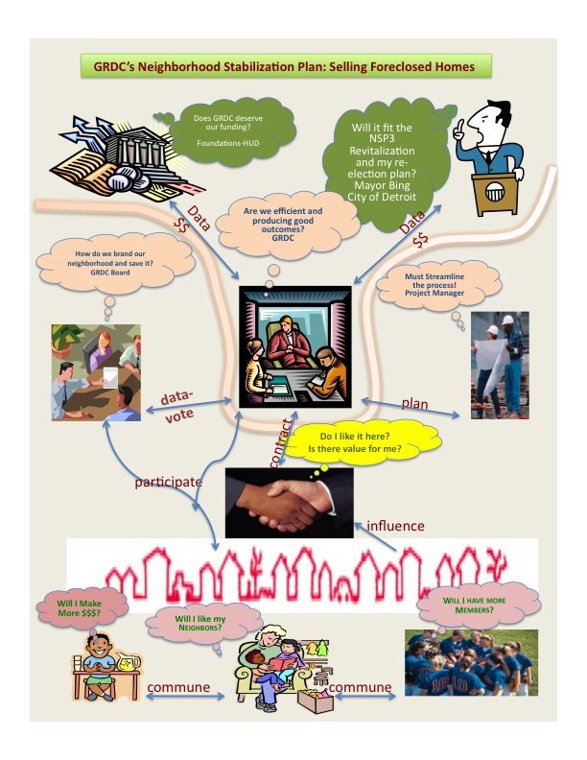

Privilege, Oppression, Discrimination and Social Justice Issues Faced By Homebuyers
Privileged residents of European background and higher socio-economic status, who as a group participated in oppression and discrimination via deed restrictions and, it is assumed, by the general attitudes that were normalized in society by the upper socio-economic groups over the past decades, once exclusively owned homes in this neighborhood. To have a diverse and predominantly African American membership is a kind of restitution. But, perhaps it will not be so, if the neighborhood fails. Many stakeholders are attempting to preserve their neighborhoods by making them safe, of economic value and filled with community relationships.

Type of resident participation

Arnstein’s Ladder of Participation
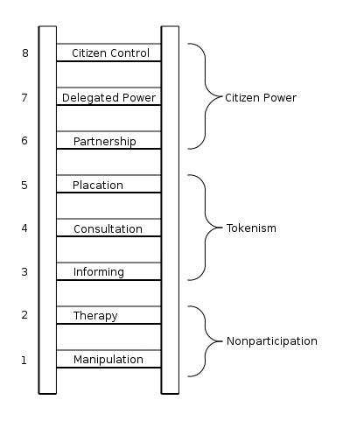
Arnstein’s Ladder of Participation is a theoretical model, which suggests that the highest level of citizen participation and power occurs when historically oppressed people, directly affected by policies, hold most of the decision-making positions. Because the staff and board members at GRDC are neighborhood residents, the level of resident participation is represented by the highest rungs of the ladder—in the Citizen Power category.

Strengths, Resources, Needs and Weaknesses of Marketing Strategies for Homebuyers

SWOT Analysis – Attracting Homebuyers
Strengths, Weaknesses, Opportunities and Threats of the marketing strategies to attract homebuyers were analyzed and are represented in the chart.
Strategies include:

Traditional Settings

* Real Estate Agent and MLS listing
* Lock box showings

Non-Traditional Settings- (GRDC only)
- GRDC Annual Neighborhood Open House May Day Kick-off
- GRDC Monthly newsletter
- GRDC Weekly E-blast
- Word of Mouth through board members representing Neighborhood Organizations
- Word of mouth through GRDC staff as residents.

As displayed in the SWOT analysis, barriers to attracting new homebuyers are the quality of public schools, perception to safety and economic value, and general desire for living in Detroit with its reputation, along with questions involving full diversity and acceptance. Non-traditional resources, such as marketing through churches, barbershops, schools or other neighborhoods within the city and outlying areas of Detroit, and to other ethnic and gender group organizations, is not included in GRDC’s marketing plan.

Barriers are the weaknesses and threats. If any barriers can be eliminates or reduced, than the strengths and opportunities will naturally outweigh the deficits and presumable more homebuyers will be attracted to the neighborhood.

Strengths  - Traditional Sales Method With Agent  - E-blast/newsletter to Large Databank  - Community-Based and Community Responsive  - Physically Beautiful Neighborhoods – Parks and Playing Fields  - Many Neighborhood Activities  - Close-By to Top Private School  - Good Prices and financing available  - Turn-key Home  - Fully Funded Program  - Close to Downtown, but Upscale Park-Like Setting | Weaknesses  - Detroit’s Viability questioned?  - Crime  - Low Home Values  - Poor Elementary Schools  - Neighborhood at Economic Tipping Point?  - Marketing Without Non-Traditional Resources
Opportunities  - Stunning Homes at Bottom Market Pricing  - Appealing Financing Programs for Lower and Middle Incomes Buyers  - A neighborhood Where Residents Talk to Each Other- Make Friends.  - Activities to Access Nearby | Threats  - Will I Like It Here?  - Is Detroit Viable?  - Safety Concerns  - Can I Afford It?  - Will I Make friends With Others Like Me?  - Can I Be My Authentic Self and Be Accepted and Welcomed?
Force Field Analysis

Each force is given a score, based on the strength of the force. Scores range from weak (1) to strong (5).

Forces Targeted for Modification

The following strategies are likely to reduce the strength of restraining forces by at least 10 points and improve the probability of success:

- Expand marketing outreach to include communities and neighborhoods outside of Detroit in an attempt to reverse flight.

- Expand marketing to non-traditional resources like gender, ethnic and religious groups to promote true diversity in assuring a welcoming message.

- Expand the Ambassador Program after the May Day Open House in outreach to these other groups.

- Secure Staging Furnishings.

Forces against Home Sales
Forces for Home sales

MLS Listing and RE Agent | 5 |  |  |  | 5 | Detroit Economic Reality
Foundation and Gov funding | 5 |  | Marketing: Strategies to Sell Foreclosed Homes  Decision-Makers:  Executive Staff  Board of Directors |  | 2 | Limited Use of Ambassadors
Renovation Program | 5 |  |  |  | 2 | Staging Program Tenuous
Homebuyer Assistance Programs | 5 |  |  |  | 2 | Intern management leaving
GRDC Data Bank Marketing  E-blast & newsletter | 3 |  |  |  | 2 | No Outreach to Gender Group Communities
Staging Program | 4 |  |  |  | 2 | No Outreach to Ethnic Community
May Day Open House | 2 |  |  |  | 2 | No outreach to Religious Groups
Volunteer Ambassadors | 2 |  |  |  | 4 | No Outreach Outside of Neighborhood Itself
Executive and Board- Directed Neighborhood Branding | 5 |  |  |  | 3 | Neighborhood Branding Goes Wrong
Total | 33 |  |  |  | 24 | Total
V. Engagement Plan

Reaching Homebuyers – Who Are They?

GRDC wishes to repopulate the neighborhoods in order to maintain property values and community cohesion. Vacant homes reduce property values and encourage crime. GDC is a nondiscriminatory non-profit. Therefore, it is presumed that an inclusive marketing campaign would be generated. Existing marketing structures that are in place will be used. This outreach reaches a predominantly African-American population. Other non-traditional marketing resource might be courted and enlisted both within and outside the neighborhoods, and into the greater Metro Detroit communities. Outreach into many types of community groups including those typically oppressed will promote diversity. As long as homebuyers are eligible for loans and are law-abiding citizens, all persons should be targeted.

Social Change and Community Practice Theories relevant to the Home Marketing Programs

Social justice theory exemplified within this program is a combination of Market and Marxist. Market theory is economic theory based on supply and demand. Since real estate is considered a commodity for asset development, property values are regulated by these factors. Marxist theory reflects the sentiment of “to each according to ability and to each according to their need”. In this regard, the homes are sold within the marketplace to those able to either make the purchases within the standard banking and purchasing legal systems, or with loan and grant assistance to others that may not qualify for a home purchase otherwise. With these home-purchasing assistance programs, a redistribution of wealth to a small degree is facilitated. Empowerment theories of social change in engaged when residents and homebuyers participate in the neighborhood stabilization and contribute to their own asset protection and attainment.

Urban activist, Jane Jacobs, writes In her book, The Death and Life of Great American Cities, 1961, of neighborhoods of choice which are defined by street life and activity on the sidewalks and of, course, compactness without stretches without life. Vacant homes are the antithesis of life, and this type of blight kills community cohesion. As renovated homes are sold to new families more blighted homes will be renovated quickly, attempting to cure symptoms of the undesirable neighborhood from becoming entrenched.

Collaborating with other settings

Non-traditional settings might be contacted to expand advertising and outreach. Promoting the newly branded neighborhoods and advertising the value and values practiced within theses neighborhoods, and inviting members of the various groups to consider purchasing homes and resettling in Grandmont-Rosedale. Flyers and ads within the group’s newsletters and bulletins, ambassador visits to meeting to present the neighborhoods and the purchasing opportunities are strategies for outreach. Churches, gender and ethnic group hangouts, social clubs, groceries, hairdressers and barber shops, other non-profits like YMCA’s or health clubs and restaurants could be approached. Likewise, grander scale marketing with local television and news broadcasts, and marketing campaigns at the local Farmer’s Market.

Developing trust & respect, addressing mistrust

Developing trust within the African- American and other historically oppressed ethnic or racial groups within this neighborhood might begin with empowerment of the existing residents through decisions about which values will be represented and “branded” into the marketing campaign. Sitting in on a board meeting in which the marketing consults presented a draft of their key finding and recommendations, many African American resident members objected to the use of the word “Historic” as a representing positive values in the marketing brochure. “Historically” the physical aspects of the neighborhood were positive. Using the word “historically” could also be “code” that might carry on today exclusionary discriminating and racist practices – clearly a misrepresentation. Developing trust may mean being tested by oppressed groups before a positive reputation can be earned.
Engagement Model Addressing Social Justice
The most valuable community process aspect that I have witnessed was in observing the
board meeting, which is made of neighborhood association leaders and other neighborhood residents. GRDC hired a marketing consulting firm who presented the key values to be promoted based on community research of many neighborhood stakeholders as the basis for their recommendations. They presented their recommendations and accepted feedback from which to modify and enhance the culturally competent marketing message. Marketing expansion by sending inclusive messages to other oppressed groups not already obviously represented could make homebuyer outreach more expansive and prevent unintended barriers of membership and inclusion.

Addressing social justice issues and other conflict

By using symbolic logos in doorway entrance windows reflecting an array of oppressed groups, a non-verbal message of welcome is extended to potential homebuyers. An example is placing a small rainbow flag on display to welcome authenticity for persons of non-bilateral gender description to community membership. It is likely that some residents of our neighborhoods are gay, but perhaps do not feel they can freely express themselves. This may be true of individuals from other oppressed groups. Currently there is a dominance of African-Americans in the community. The community is not very diverse. GRDC could reach out to other ethnic communities via advertising in their newspapers and organizational newsletters.

Evaluation

Ultimately the number of homes sold will evaluate the success of the Marketing Program. Other measures can be: length of time on the market, profit margins on sold property (instead of price reduction to guarantee a sale), diversity of homebuyers and homebuyer adaption to the community (volunteering or membership in community activities and organizations).

